1. 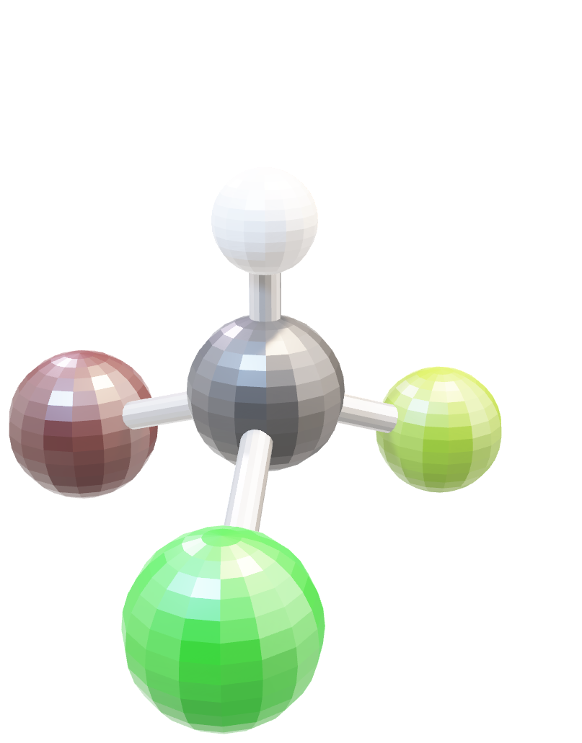The 2 molecules directly below are the same (bromochlorofluoromethane).
   1. Are they mirror images of each other?
   2. Click on the molecule on the right. Move and rotate* the molecule so that it overlaps (superimposes) the molecule on the left? Can you overlap all the same atoms on top of each other? *\* Mobile phones and some tablets may not allow for this molecule to be moved.*

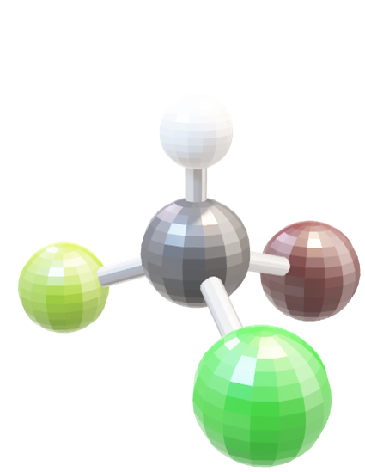

*Mirror plane*

What if we replaced the fluorine atom for another hydrogen atom shown in the molecules below (bromochloromethane)?

* 1. Are these still mirror images of each other?
  2. Move and rotate* the molecule on the right so that it overlaps (superimposes) the molecule on the left? Can you overlap all the same atoms on top of each other?

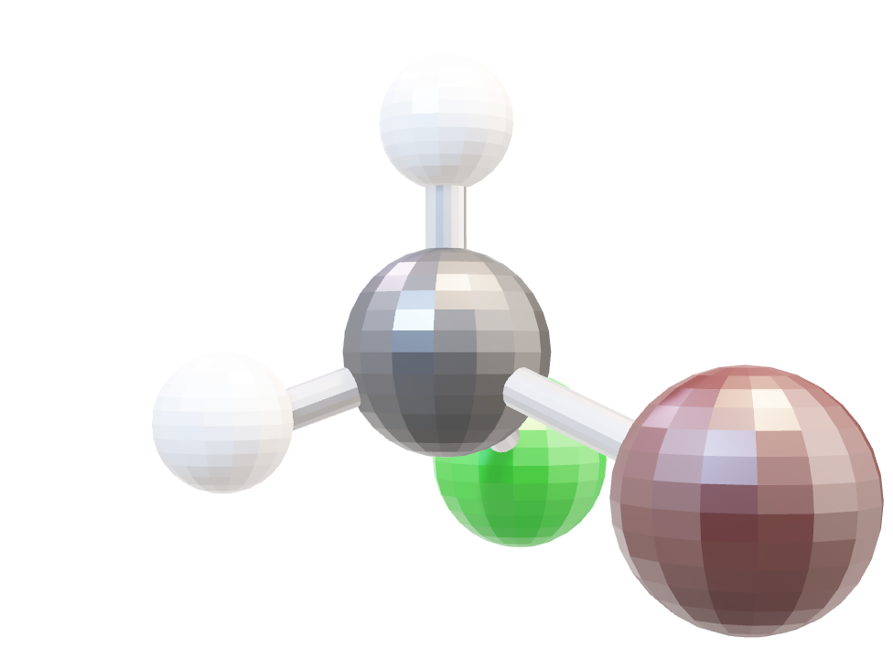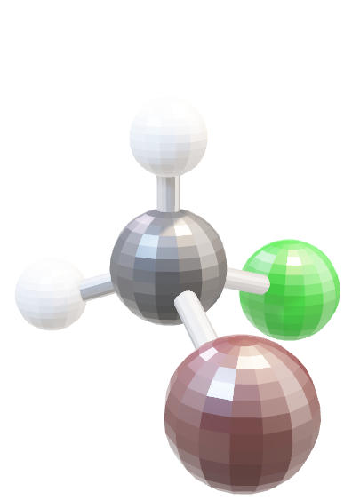

*Mirror plane*

* 1. What is the difference between the first set of molecules and the second set of molecules?

2. Click on and interact with the three molecules below.

1. How many carbon-carbon bonds are present in each molecule?
2. Which one is ethane, ethene and ethyne?
3. Describe the overall geometry or shape of each molecule.

|  |  |
| --- | --- |
| Number of carbon-carbon bonds:  This molecule is: ethane / ethene / ethyne  Geometry or shape: |  |
| Number of carbon-carbon bonds:  This molecule is: ethane / ethene / ethyne  Geometry or shape: |  |
| Number of carbon-carbon bonds:  This molecule is: ethane / ethene / ethyne  Geometry or shape: |  |

